[ENIGMA]

Project Design Document

1. Design Intent
We are trying to create an immersive horror mystery game, where users interact with a pivotal piece of the mystery, and try to solve the given case. This project is mainly for users that value a unique experience over a product, as our immersive horror mystery game is binary, and only involves one story with a predetermined outcome.

2. Inspiration & References
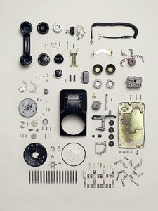
This project is inspired by the mechanism behind retro phones, and majorly involves UI-UX design.

We learned the complexities of electrical engineering involved in a simple rotary phone, and simplified the same to fit our current hardware and software knowledge.

3. User Journey
1. User picks up the phone, and audio begins playing on the webpage.
2. Webpage presents first part of the story, and the attached riddle.
3. User solves the riddle, and receives a number.
4. User inputs that number on the phone.
5. Webpage presents second part of the story, and another riddle.
6. User continues learning parts of the story, and solves riddles that relate directly to the story’s main mystery.
7. At the final stage, the webpage presents the user with a morse code manual.
8. User spells out the name of the real culprit using morse code over the attached mystery box.
9. If the mystery box reads the correct morse pattern, it automatically opens, revealing the true events of the case.

4. Success Criteria
Measurable success:
- User feels immersed in the experience.
- The phone is functional, it registers numbers and movements, without any additional problems.

5. System Overview
- High-level explanation of system
- What are the main parts?

6. High-Level Block Diagram
👉 Visual diagram of system components and flow

7. Input / Output Mapping
Input | Process | Output

8. Sketches & Concepts
- Hand sketches / early ideas
- Iterations

9. Final System Architecture (Labelled)
👉 Clear diagram showing all components and connections

